# Bahria University,

**Karachi Campus**



**LAB EXPERIMENT NO.**

## 09

**LIST OF TASKS**

|  |  |
| --- | --- |
| **TASK NO** | **OBJECTIVE** |
| **01** |  |
| **02** |  |
| 03 | **Access your university website and list IP address of your computer, DNS address and default gateway.** |

**Submitted On:**

## Date: 13/12/2023

**TASK #01: What is the internet address of gaia.cs.umass.edu?what is the internet of your computer?**

**SOLUTION:**

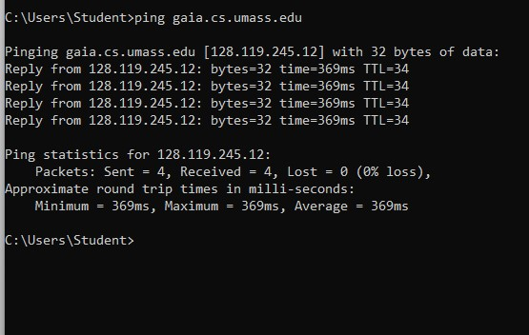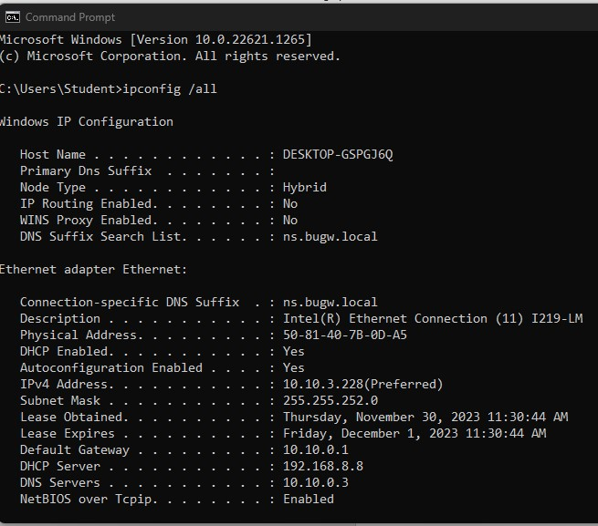

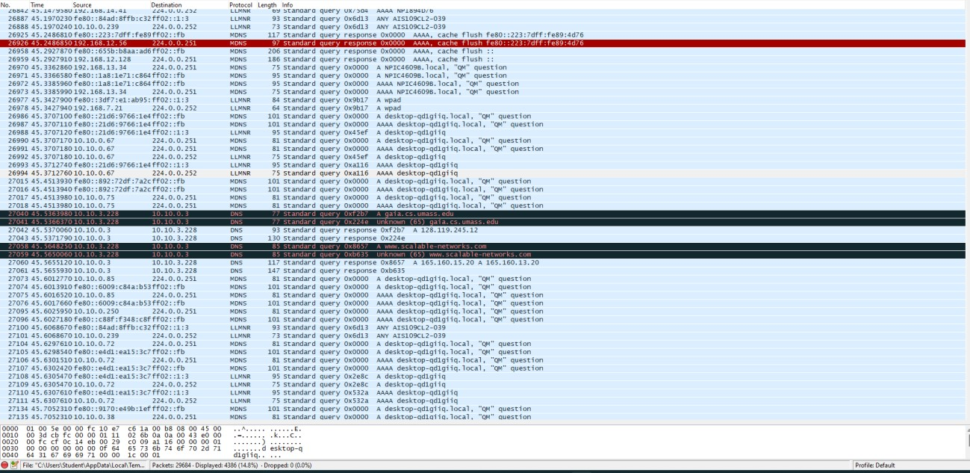

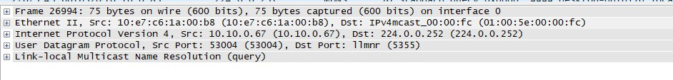

**TASK #02**: Fill the chart.

**SOLUTION:**

|  |  |
| --- | --- |
| Parameter Name | Value |
| Your PC IP Address | 10.10.3.226 |
| Your PC MAC Address | 50.81:40.7b: |
| Default Gateway | 10.10.0.1 |
| Website Access | gaia.cs.umass.edu |
| Website IP Address | 10.10.0.3 |

Table 1 PC Details

|  |  |  |
| --- | --- | --- |
| Parameter Name | Field Value | Field Length |
| Source MAC address | 9c:b6:54:03:el:6a | 48 |
| Destination MAC address | 50:81:40:7a:da:3c | 48 |
| Destination TCP Port | 52826 | 43 |
| Source TCP Port | Domain(53) | 16 |
| Website DNS address | Gaia.cs.umass.edu | 152 |

**TASK #03:** Access your university website and list IP address of your computer, DNS address and default gateway.

**SOLUTION:**

